Let's-Talk-Leadership
Help Your Employees Do More in Less Time

by Karla Brandau, CSP
CEO of Workplace Power Institute

Because of thunder storms in Atlanta, the flight from Dallas to Atlanta had been delayed twice. On the third attempt, we were boarding and I felt hopeful of actually getting off the ground. My hopes faded fast when the tired-looking flight attendant came down the aisle quietly announcing that if we were not permitted to take off in the next 15 minutes, the crew would have exceeded their 16-hour work day and we would have to taxi back to the terminal and await another flight.

We were not given permission to take off, the crew's time expired and as we taxied back to the terminal I felt mixed emotions. I kept thinking, "But we were right there ready to take off. How could 1-1/2 more hours matter?"

Just as airlines are concerned about overworked pilots and flight attendants, employers should be concerned about overworked employees. Why? Errors, accidents, and low productivity for a start.

My mixed emotions as we taxied back to the terminal are similar to the signals our culture sends today about long work hours. In one breath we agree with employees having a pity party about how hard they work and with the other breath, we award employees a "red badge of courage" for having the guts to go the extra mile.

A study by the Families and Work Institute concludes that overworked employees should be taken seriously. Employees who are overworked are more likely to exhibit anxiety, make mistakes at work, harbor angry feelings about their employer for expecting them to be on the job for long hours and resent coworkers who don't pull their share of the load. The study documents that nearly half of employees who feel overworked report that their health is poor and 8 percent of employees who are not overworked experience symptoms of clinical depression compared with 21 percent of those who are highly overworked.

Helping Employees Feel Less Overwhelmed

What can the organization do to help employees feel less overworked while still finishing their tasks in a given day? Using time efficiently at work is an individual and an organizational issue. On the organizational side, managers can help employees reduce the feeling of being overwhelmed by:

- Training employees in time management principles
- Discouraging the practice of eating at the desk and working through lunch
- Insisting employees taking vacation time
- Permitting flexible work hours when appropriate
- Encouraging non-interrupt zones in the day when workers can focus on their tasks
- Assigning tasks well in advance of the drop dead date
- Helping Employees Be More Effective

A tried and true principle states that to be efficient, you must first be effective. For instance, the maker of buggy whips might be highly efficient in manufacturing techniques, but if no one buys the buggy whips, the process is not effective.

To encourage efficiency and effectiveness, managers can:

- Have clearly stated goals with built in deadlines
- Insist employees make a daily "to do" list
- Make certain equipment works properly
- Supply the necessary materials for job completion
- Train employees on software packages that enable more efficient work

Ensuring the above items are taken care of is essential to help employees leverage their time while in the office and be more productive.

Realizing a Productivity Culture Change

Managers should make a concerted effort to grease the wheels of productivity, and not be the stick that gets caught in the tire spokes, catapulting the rider from the trail. By attending to these issues, managers can help workers feel less overwhelmed and enable them do more in less time. You'll like the results.

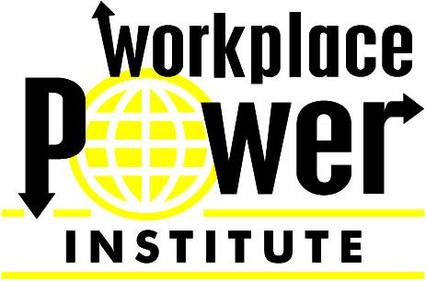
You may reprint this article in your organization's newsletter or reproduce it on your web site as long as you keep this byline intact:
Karla Brandau, CSP, is the CEO of Workplace
Power Institute. She is an expert in making your workforce more productive from leadership and team building to professional development. To revolutionize the way your managers get results, call Karla today at 770-923-0883 for a customized keynote, breakout session or in-house workshop. Her principles break down invisible walls and decrease miscommunication. Visit her at www.WorkplacePowerInstitute.com or stop by
her blog at www.FromTheDeskofKarlaBrandau.com. end_of_the_skype_highlighting

